**Dry Needling Course**

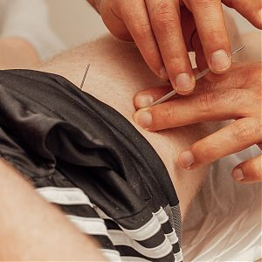This Dry Needling course is run over 3 weekends, with an examination on an additional day.

**The course is accredited by the Federation of Holistic Therapists (FHT) Ireland and the UK.**

**Over the course of 3 weekends you will be given:**

* The theory of Dry Needling compared with Traditional Chinese Medicine.
* Practical knowledge and application of 3 DIFFERENT needling methods.
* A safe learning environment to have discussions and get answers.
* A research based foundation to this ever evolving field.
* Health & Safety guidelines and practices to assure safe treatments for you and your clients.
* Contraindications for needling, according to each and every method.
* Anatomical revision of 32 muscles and 22 nerves.
* Physiological implications of Dry needling on the body and its impact on physical pain.
* A qualification accredited by the Federation of Holistic Therapists (FHT) in Ireland and in the UK.
* Practical experience with case studies.
* Confidence to implement the modality as soon as the course is over.
* Insurance approved method to apply better treatments to a large variety of conditions coming to your clinic.
* Continuous support after the course is over for any questions you may have.

The aim of Dry Needling is to reduce muscle pain and dysfunction by releasing oversensitive areas in the muscle known as myofascial trigger points. When Dry Needling is applied to an affected muscle or trigger point, it reduces muscle tightness and pain, while increasing blood flow and range of motion. Patients often report immediate relief after treatment.

**It is an ideal course for practicing therapists who wish to add an efficient skill to their skillset.**

**Course Requirements:**   
Minimum Level 3 Massage Therapy (or equivalent)

**Course dates:**

* August 31st & September 1st,
* September 14th & 15th,
* September 28th & 29th.
* Exam on October 5th.

**Times:**   
10 am to 5 pm (Saturday & Sunday)

**Venue:**  
International College of Orthopaedic Therapy (INCOT), Exchange House, Main Street, Ballincollig, Co Cork.

**Course Fees: €1,350.**

Booking deposit of €500 payable with application  
Balance of €850 to be paid prior to starting the course.

For further details contact INCOT at: 021 2417762 or 086 6613997  
**Email:** incotcork@gmail.com

**Click Here for an Application Form:** [Online JotForm](https://form.jotform.com/233412361941349)

**Please contact us below and we will get back to you!**

Call 021 2417762, or reach us on mobile at 086 661 3997. Please email incotcork@gmail.com with any enquiries, thank you!