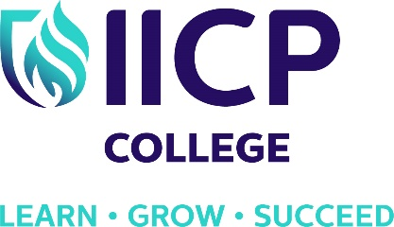

Master of Science in
Pluralistic Counselling and Psychotherapy

October 2022

Due to the current government-issued social distancing requirements, our college has been successfully transformed into a remote/blended learning community for programme delivery. The delivery of the programme remains on the cutting edge of best practice in counselling and psychotherapy education and training.

PROGRAMME AIMS

Developed in conjunction with Visiting Professor John McLeod, this programme aims to enable existing professionals working within the field of counselling and psychotherapy to achieve a Master of Science in Pluralistic Counselling and Psychotherapy.

COURSE STRUCTURE

The programme consists of ten modules over two years. It is a taught Master’s with a strong research component. The programme utilises a Continuous Assessment Strategy and learners accumulate credits though a variety of assessments over the duration of the programme.

STUDENT BENEFITS & SUPPORT

IICP is an engaging, dynamic and supportive institute within which to study. We pride ourselves on our ethos of student support, ensuring that learners are guided and encouraged throughout the programme. The MA training promotes respect for all therapeutic models whilst advocating personal responsibility and lecturer flexibility and understanding.

WHO SHOULD APPLY?
This two years Programme will be of interest to practising therapists who wish to extend their existing qualification in counselling and psychotherapy to Master’s level.

ENTRY ROUTES:
- Evidence of successful completion of a Level 8 Degree in Counselling and Psychotherapy and evidence of completion of additional course requirements including 50 hours of personal therapy and 100 hours of supervised clinical practice.
OR
- An undergraduate degree (Level 8 on the NFQ) plus a professional diploma programme in Counselling and Psychotherapy that meets with IACP /IAHIP Course Recognition standards.
OR
- Recognition of Prior Learning and Experience is also taken into account.

VALIDATION OF AWARD:
This programme is validated by QQI as a Level 9 Master’s Degree in Counselling and Psychotherapy.

PROGRAMME CONTENT:
The programme contains ten modules over the duration of two academic years. For more detail visit www.iicp.ie/courses/masters

PROGRAMME LECTURERS:
- Professor John McLeod
- Professor Michael O’Rourke
- Dr. Marcella Finnerty
- Dr. Maria Quinlan
- Mr. Padraig O’Morain
- Mr. Dermot O’Neill

COST: Application fee: €75
1st year Fees - €3,875
2nd Year Fees - €3,875 (inclusive of QQI registration fee of €200)

PROGRAMME SCHEDULE:
The programme is facilitated through monthly blocks of three days to include weekends.

VENUE: IICP Education and Training, Killinarden Enterprise Park, Killinarden, Dublin 24

DATES: Starting October 2022

For further information call visit www.iicp.ie/courses/masters
or contact the IICP Office
Phone: 087 905 5330
Email: admissions@iicp.ie

Triona Kearns
Director of Registry & Operations
Phone: 086 0499154

Marcella Finnerty
College President
Phone: 086 2609989

